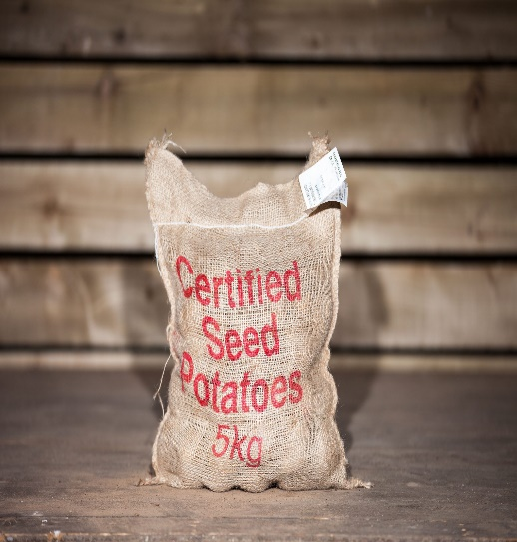

We have the following varieties of seed potatoes now in stock.

**First Earlies: Homeguards**

These reach maturity ten weeks after planting.

**Second Earlies: British Queens**

These reach maturity two weeks after the first earlies

**Maincrop: Records, Rooster,and Kerr Pinks**

The last potato to mature.

These are high yielding and have excellent storage properties

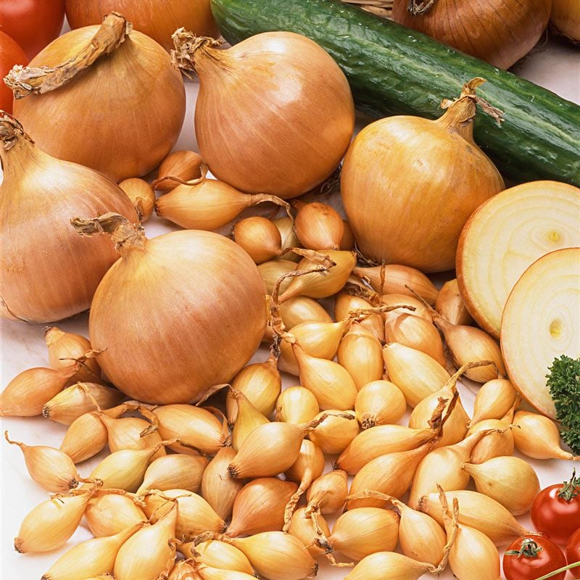

Onion Sets

And

Shallots

Now available

Ready for planting